LockedMe.com – Product Specification

1. Introduction
LockedMe.com is a file management system which will allow the user to see the files from a specific folder, add, delete and search for a specific file.

The prototype needs to be ready in 15 days, so it will need to be developed within 1 sprint(considering the usual duration of a sprint in practice is of 2 weeks).
For the scope of this prototype only the administrator will interact with the application through CLI.
Generic features and operations of the application(will be detailed later in the document):
- Retrieving the file names in an ascending order
- Business-level operations:
  - Option to add a user specified file to the application
  - Option to delete a user specified file from the application
  - Option to search a user specified file from the application
  - Navigation option to close the current execution context and return to the main context
- Option to close the application

2. Workflow
Main Menu
The main menu will display the name of the app – LockedMe.com – the designer name and three options – to display the files in the working directory in an ascending order, to enter the file edit menu and to exit the app:
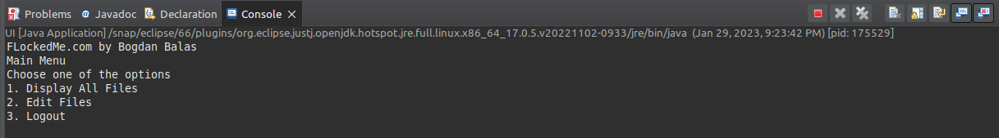
2.1 Display all files
The first option will display all the files I the working directory sorted in an ascending order. For the scope of this prototype the app is working only in the current working directory, but a path variable was defined to allow later versions to take the folder as an input from the user.
The name of the files in the working directory are stored in an ArrayList, sorted using the Collection.sort() method and displayed one per row:
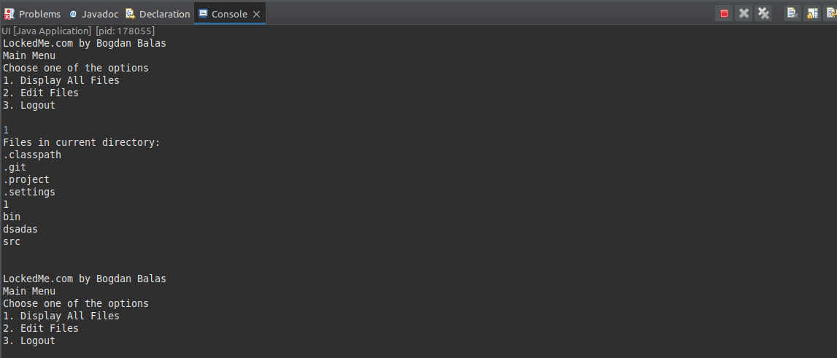
2.2 File edit menu
Upon selecting option number 2 the user is redirected to a secondary menu allowing him to edit the files:
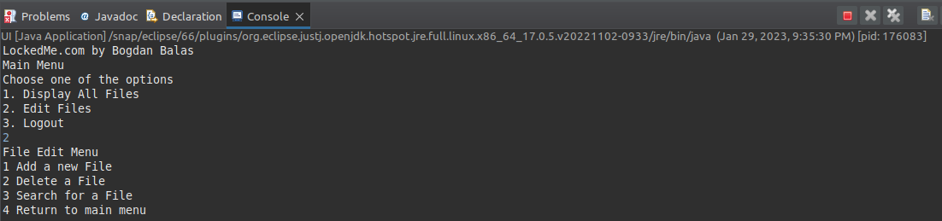
2.2.1 Adding a file
The first option of the secondary menu allows the user to add a file in the working directory. The createNewFile() method is used to test if the file can be created – in this case a success message is displayed – or if the name provided by the user already belongs to a file from the working directory:
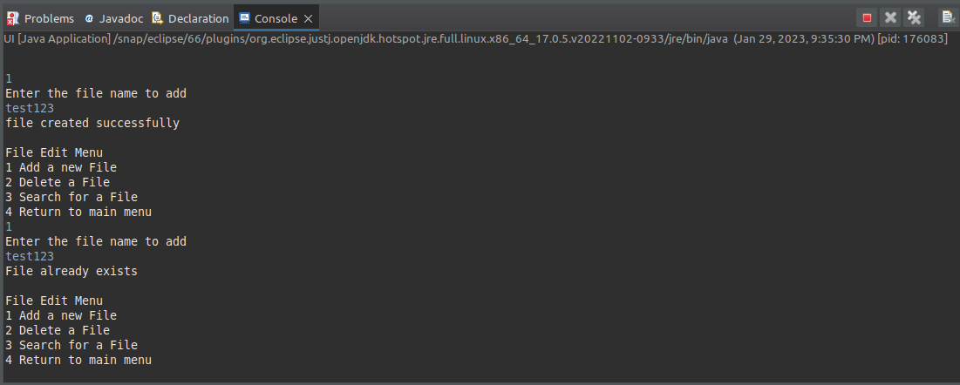
For the latter scenario the FileExist exception was defined.

2.2.2
Option #2 of the file edit menu will allow the user to delete a specific file from the working directory. If he enters a file that exists a delete success message is displayed(delete() method is used to implement the functionality) otherwise a file not found is returned.
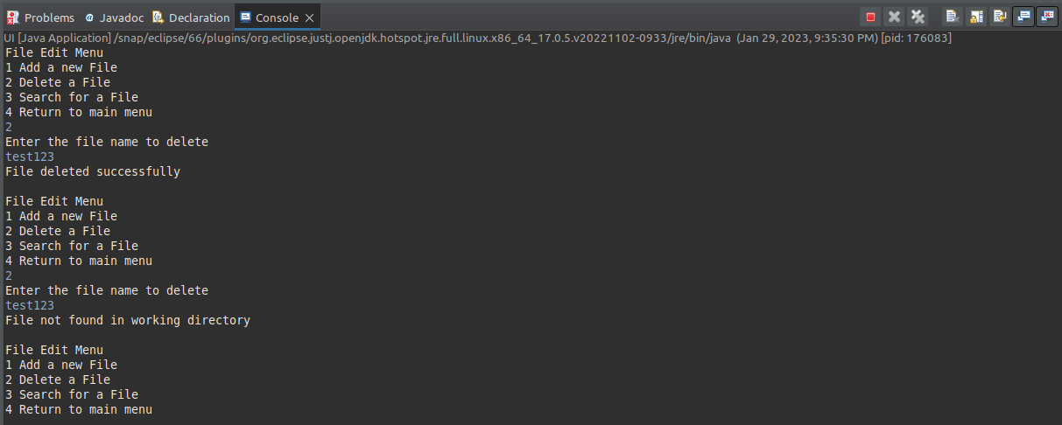
2.2.3 Searching for a specific file
The search function is implemented by transferring all the names of the files in an ArrayList and comparing each element of the list with the string(file name) the user is looking for. If the file is found a success message is displayed, otherwise a file not found exception is thrown.
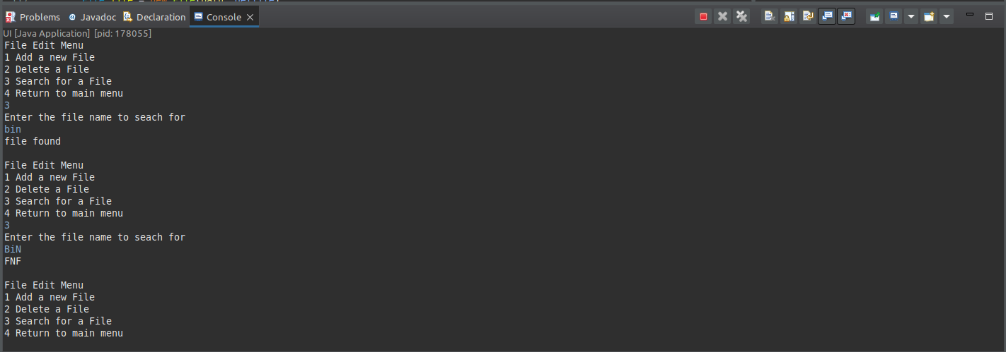
2.2.4 Return to main menu
Selecting option #4 will redirect the user to the main menu of the app:
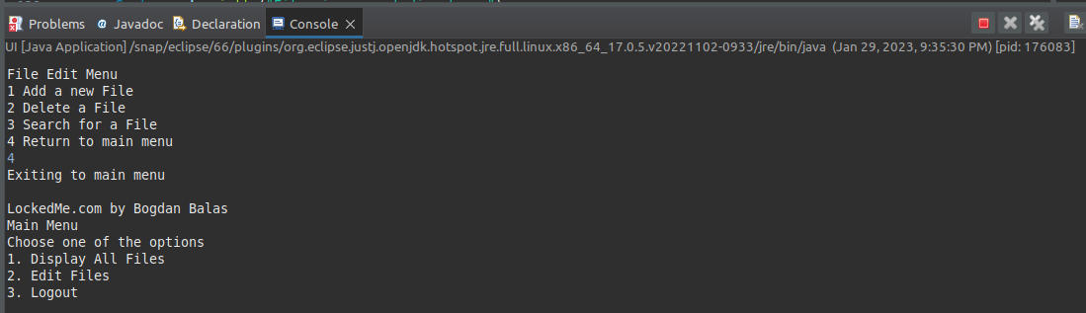

2.3 Logout
The logout option will exit the app, displaying a confirmation message.
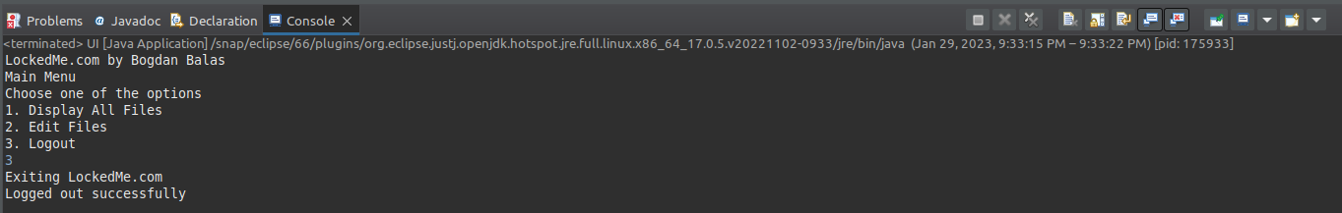
3. Application delivery schedule
As mentioned in the introduction, the 15 days given until the prototype is demoed to the business users for project approval means it needs to be developed in the first sprint of the PI(planning increment) considering 2 weeks sprints.
Sprint 2 – will be used for research; the developer will look for the best solutions to implement the file management system. If the project is approved(the demo for the Business is happening during Sprint 2) development work continues, otherwise the project is abandoned.
Sprint # 3 and #4 – three user roles with distinct privileges are defined:
- Company administrator – has access only to his company’s folder
- Support user – has access to the folders assigned to the companies he supports; can create new company accounts
- Global Admin – has access to all folders; assigns Support users to companies; can create new companies accounts
Sprint #5 – develop the functionality to upload files

By this schedule the application’s MVP will be ready for demo in the I&P sprint. Considering the PO’s approval on the functionalities was already taken during the Sprint Demo it’s just a matter of getting the Business approval before launching v1.0 of the LockedMe.com application.

